Attach ADOBE Form to the standard FIORI App (PO)
FORM TEMPLATE
1. in search bar ->open form template
2. select predelievered templates
3.search in description (example : purchase order)
4.select form with language IN ,
5.copy and make as z form (custom template)
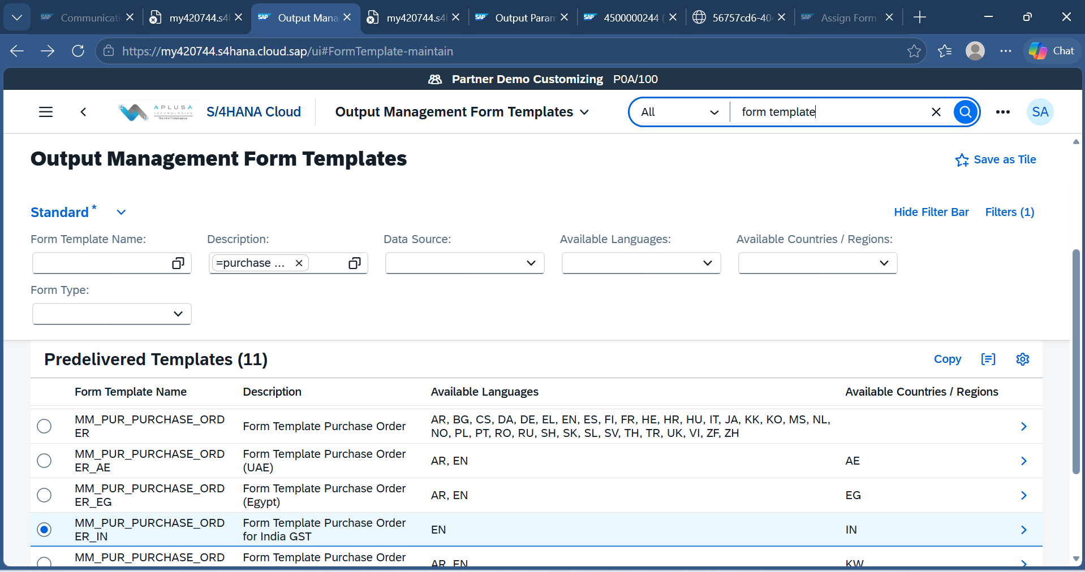
6.go to the custom templates
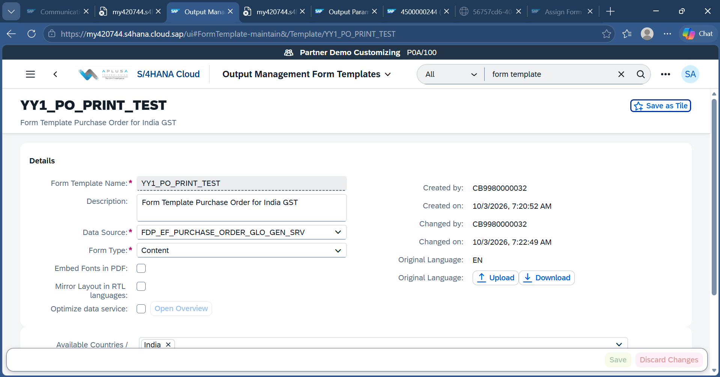
7. click download button to download & extract the template in files.
8. download ADLC (ADOBE LIFECYCLE 11.0 VERSION), and do the required customization, and save with new name .
9.come back to custom template and upload the customized templete ,in the same screen as download.
IMPLEMENTATION ACTIVITY
1.go to Implemenattion Activities -> general settings ->extensibility ->Assign form Templates
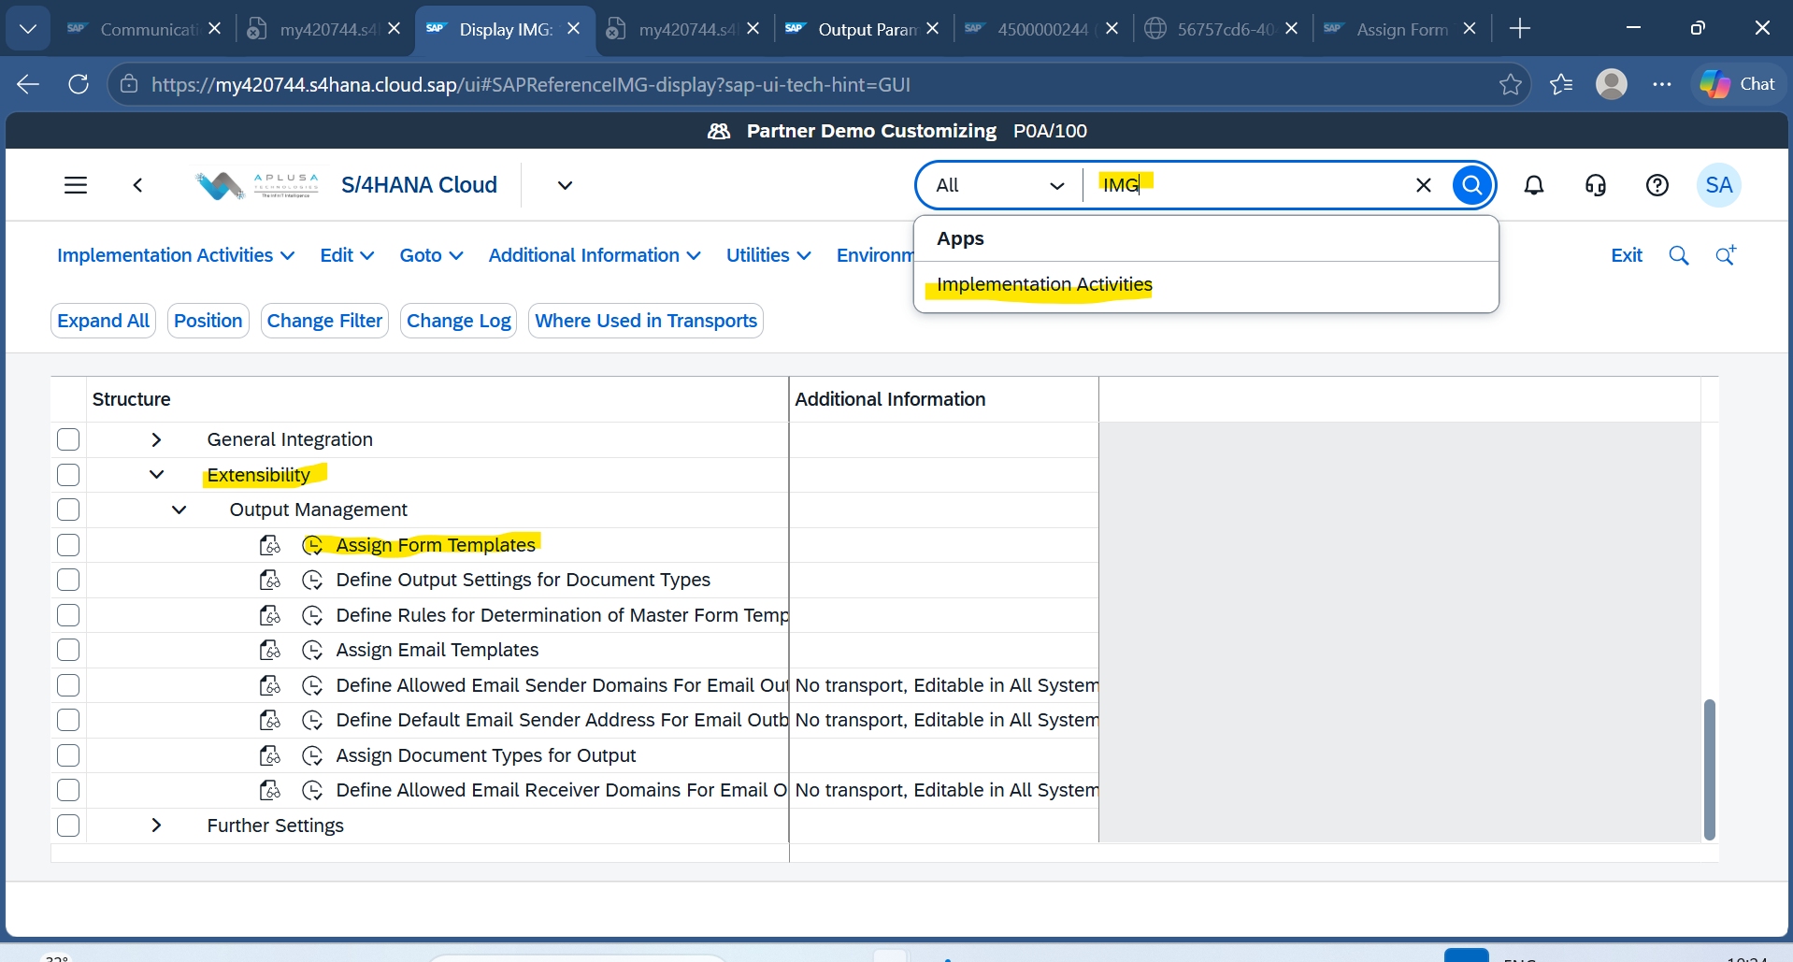
2.Click edit button and search for the template id 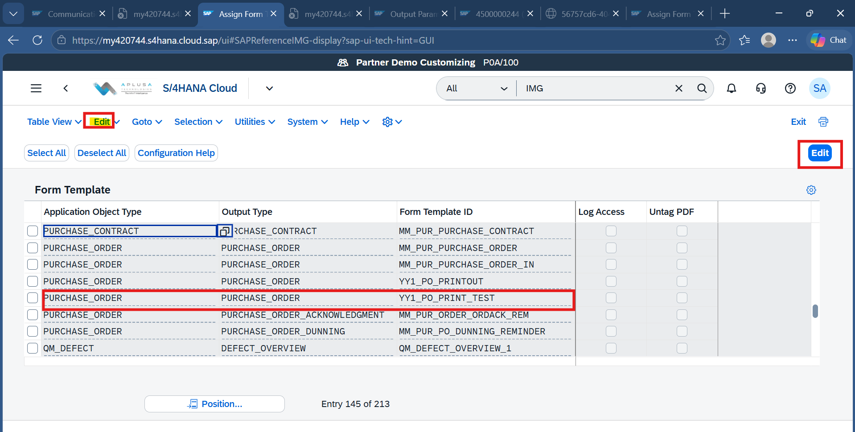
3. click on 'copy as 'button , and assign your custom template here , and click on copy
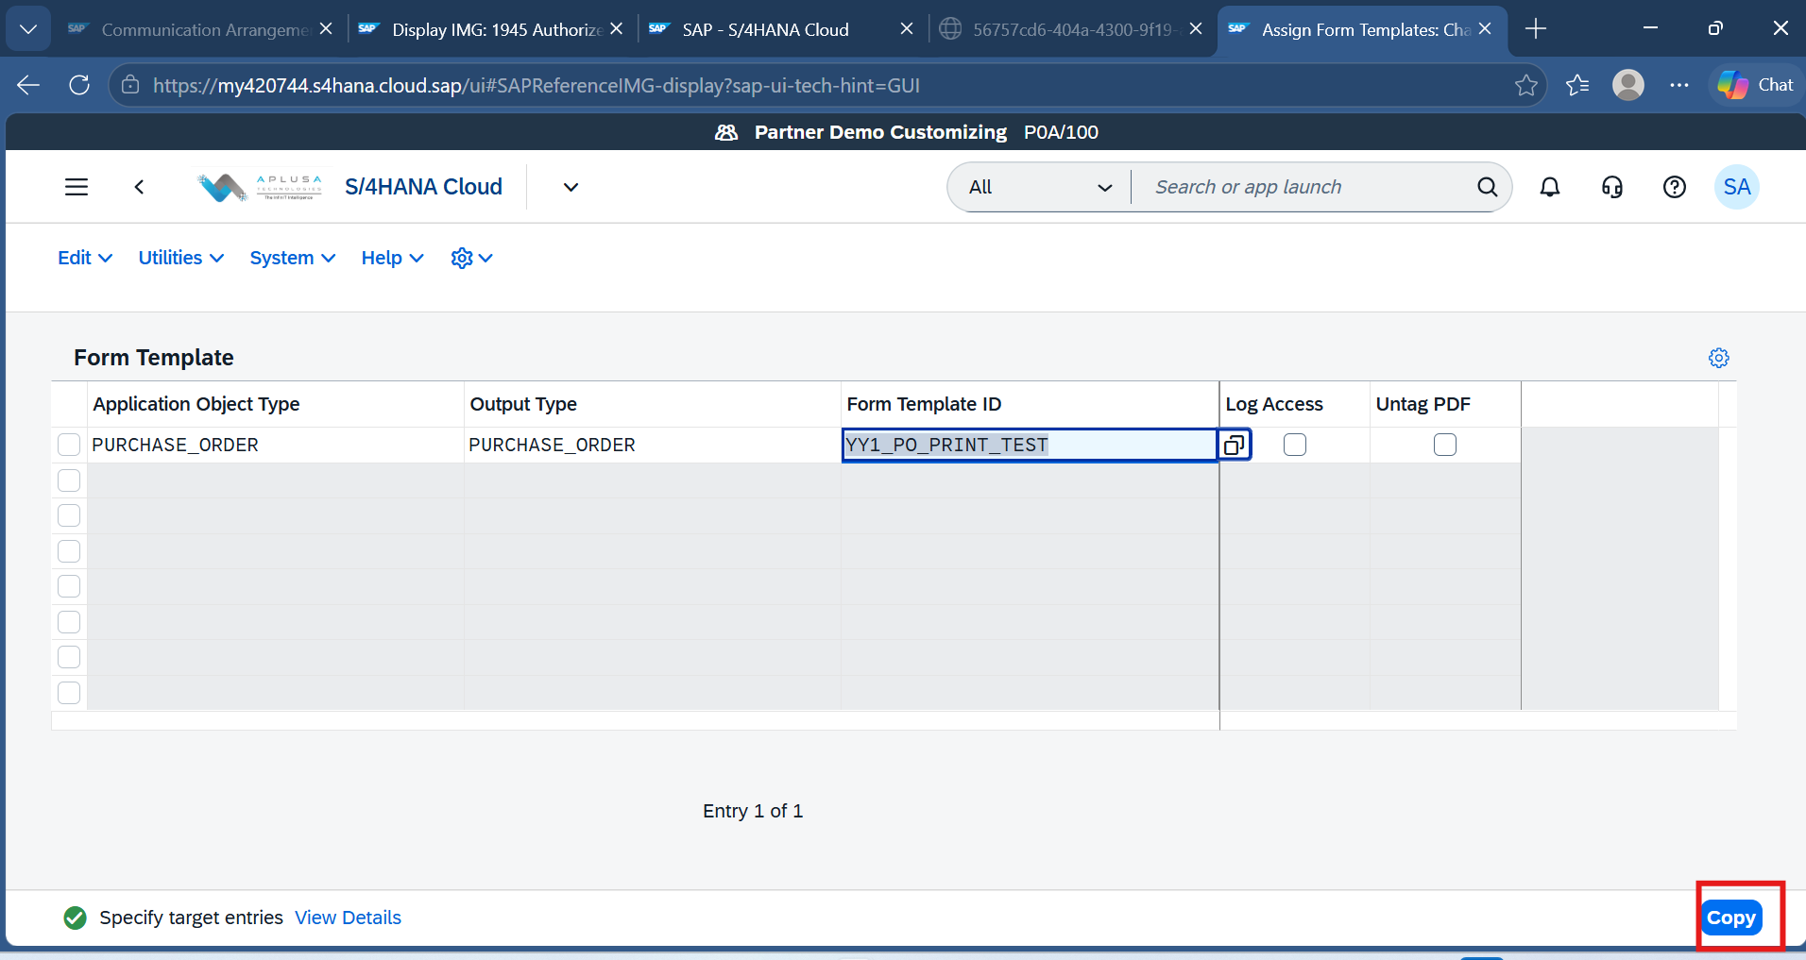
6. give the correct customizing TR .and SAVE IT .
OUTPUT DETERMINATION
1. Goto output determination app , select the show rules for and detemination step
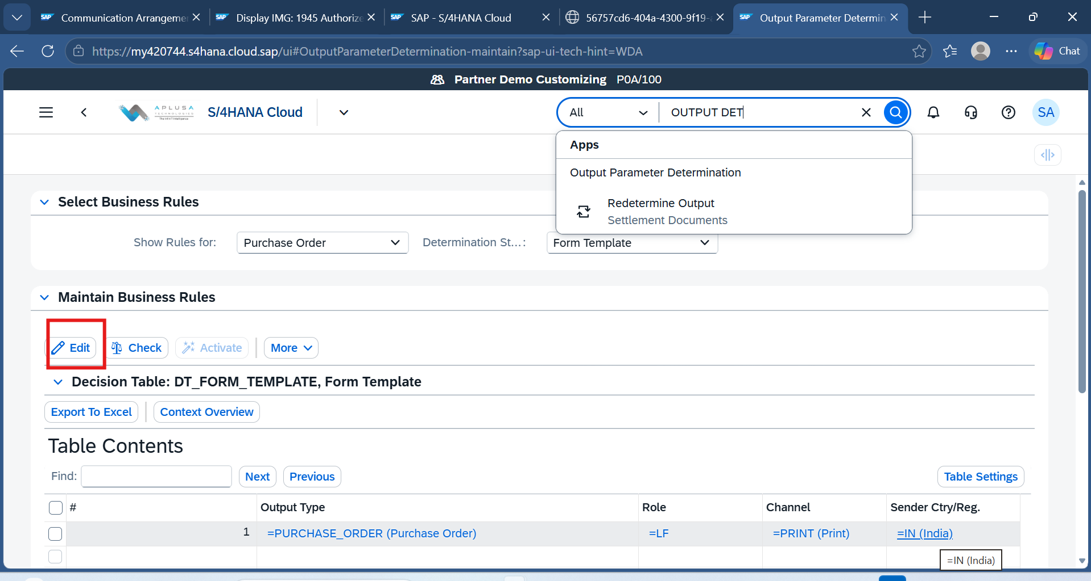
2. edit the Decision Table , select the correct row , and choose form template column.
3. select you custom z template there and save it .
Test the Form in FIORI App
